**Picture changer manual**

Hello! This is a short manual on how to use this picture changer. We won’t show what the changed images will look like but we will explain what their buttons do. Feel free to discover what the buttons do while going through or after reading this manual.

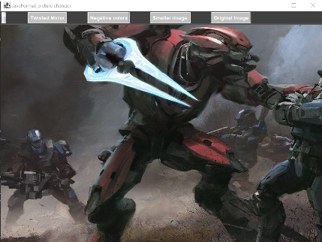

* This is the start up page which shows a menu with

four buttons in total which all have different functions

* The Twisted Mirror button changes the image into a

nonconventional mirror image, it only mirrors half the image.



* The Negative colors button changes the entire images

pixels into its negative values.

* The Smaller Image buttons changes the image into a

smaller version.

* The Original Image button does what it sounds like, it

shows the image that is first shown on program start up.